Name:_____________ Date:______________
Lesson 18 Lines and Angles Notes

A line has no beginning point or end point. Imagine it continuing indefinitely to both directions. We can illustrate that by little arrows on both ends.

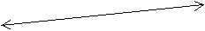

A line segment has a beginning point and an end point.

All the sides of this triangle
are line segments.

A ray has a beginning point but no end point. Think of sun's rays: they start at sun and go on forever...
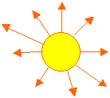

What is an angle? Many people think that angle is some kind of slanted line. But in mathematics an angle is made up from two rays that have the same beginning point. That point is called the vertex and the two rays are called the sides of the angle.
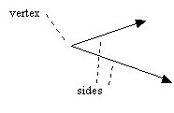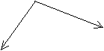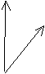
 |  | 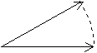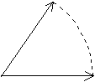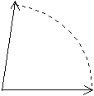
This angle is called the zero angle. |  | In each picture the angle keeps getting bigger. The arc of the circle is larger. The angle is opened more and more. These angles are acute angles, which means they are less than a right angle. Think of the acute angles as sharp angles. If someone stabbed you with the vertex of the angle, it would be sharp. (0-90 degrees)
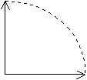 |  | 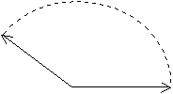 |  | 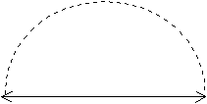
This angle is called  the right angle.  For example, table corners are right angles.  (90 degrees) |  | The angle is opened even more and is bigger than the right angle. It is an obtuse angle. Obtuse angles are dull angles.  (Between 90-180) |  | This angle is called the straight angle. (180 degrees)

Angles are commonly described as acute, right, and obtuse.

It does not matter how long the sides of the angle appear. Remember, they are rays, and rays don't have an endpoint, but when drawn on paper, they do end somewhere. The sides of the angle might even seem to have different length. That doesn't matter either. The size of the angle is ONLY determined by how much it has "opened", or how big part of a arc of a circle the sides have drawn.
Which of these two angles is bigger?  Remember to look at how much  the angle has opened, or how big  part of a circle the sides have drawn. | 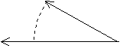
Many times the arrows are omitted  from the rays, and the arc of the circle  is drawn as a very tiny arc near the vertex:  Even the little arc is not necessary. | 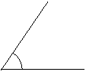 | 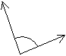

New terms to remember:
- a line  - a line segment  - a ray  - an angle | - a zero angle  - an acute angle  - a right angle  - an obtuse angle  - straight angle

Name:_____________ Date:______________
Lesson 18 Lines and Angles Student Notes

A ___________has no beginning point or end point. Imagine it continuing indefinitely to both directions. We can illustrate that by little arrows on both ends.

A ____________ has a beginning point and an end point.

All the sides of this triangle
are line segments.

A _________ has a beginning point but no end point. Think of sun's rays: they start at sun and go on forever...

What is an angle? Many people think that angle is some kind of slanted line. But in mathematics __________ is made up from two rays that have the same beginning point. That point is called the vertex and the two rays are called the sides of the angle.
This angle is called the ______angle. |  | In each picture the angle keeps getting bigger. The arc of the circle is larger. The angle is opened more and more. These angles are _________, which means they are less than a right angle. Think of the acute angles as sharp angles. If someone stabbed you with the vertex of the angle, it would be sharp. (0-90 degrees)
This angle is called  the _________.  For example, table corners are right angles.  (90 degrees) |  | The angle is opened even more and is bigger than the right angle. It is an ________. Obtuse angles are dull angles.  (Between 90-180) |  | This angle is called _____________. (180 degrees)

Angles are commonly described as acute, right, and obtuse.

It does not matter how long the sides of the angle appear. Remember, they are rays, and rays don't have an endpoint, but when drawn on paper, they do end somewhere. The sides of the angle might even seem to have different length. That doesn't matter either. The size of the angle is ONLY determined by how much it has "opened", or how big part of a arc of a circle the sides have drawn.
Which of these two angles is bigger?
Remember to look at how much
the angle has opened, or how big
part of a circle the sides have drawn.
Many times the arrows are omitted
from the rays, and the arc of the circle
is drawn as a very tiny arc near the vertex:
Even the little arc is not necessary.

New terms to remember:
- ___________  - ___________  - ___________  - ___________ | - __________  - __________  - __________  - __________  - __________

Name:_____________ Date:______________
Lesson 18 Lines and Angles Written Practice
1. Michael estimated that there were nine tables in the room with about six people seated at each table. About how many people were seated at the tables?

2. The temperature at 8 am was 65 degrees F. By 11 am, the temperature increased 17 degrees. What was the temperature at 11 am?

3. Of the fifty customers, 35 bought the advertised item. What fraction of the customers bought the advertised item? What percent?

4. How many cups are in 3 gallons?

5. Cleo walked 3 miles in 45 minutes. What was his average rate in minutes per mile? In miles per hour?

6. Compute a 15% tip for a dinner bill of $40.

7. Solve for x. 8. 5 + x =13 9. $\frac{2X}{5}$ = 10
X – 13 = 20

10. Describe each:

1. 2. 3. 4.

___________ ____________ ____________ ____________

5. 6. 7. 8.

___________ ____________ ____________ ____________

